OUSE VALLEY CHECK 8 OCTOBER 2020
Carried out by Caroline Underwood and Melanie Storey from Buckden Parish Council and David Gillbanks and Peter Riley from Offord Parish Council
The check was carried out after a period of very wet weather in the previous 2/3 weeks. The path became impassable because of flooding and the full survey had to be curtailed. It is suggested that in any information about the walk published the possibility of the route being impassable because of flooding should be mentioned .

Summary
The key point we wish to make is that this part of the Ouse Valley Way is probably one of the least accessible parts of the path. At points the path is very narrow and slopes dangerously towards the river. The view of the those carrying out the survey is that the hedge on the field side of the path needs professional cutting back ,this would allow walkers to walk nearer to the field edge and there would be less wear and tear on the river edge.
We believe that the priority for funding must be to make the path accessible rather than producing information boards. There is little point in information boards if people cannot actually walk the path.

We used, as suggested the What3words app to designate the areas we are referring to.
Category
A | Is the path safe, especially when close to the river?
B | Are there obstructions and can these be removed by volunteers or by professionals?
C | Is the waymarking clear?

Ref | Location | Issue/s | Category
1 | boldest.airstrip.worlds | Anglian Water Authority eel works signs littering side of path | B – AWA need to collect
2 | investors.return.awake | Northern entrance to bridge subject to flooding | B
3 | pits.infects.cakewalk | Western entrance to bridge flooded | B
4 | typist.dentistry.brimmed | Water nearly at point where would cover bridge | A - unsafe
5 | extreme.builders.nip | Kissing gate impassable due to flooding SEE PHOTO | B
6 | annual.routing.various | Kissing gate impassable due to flooding from river | B
7 | handy.elated.louder | Bank infested with Himalyan Balsam | B - professionals to remove
8 | bluffing.hood.blissful | Bramble growth forcing people on to narrow path sloping steeply towards river SEE PHOTO | A - unsafe  B - professionals to remove brambles
9 | buffoon.flippers.slicers | Bank eroded, path flooded, incursion by brambles and low overhanging trees | A - unsafe  B - professionals to remove brambles
10 | remodels.slung.approve | Bank of river breached by severe erosion and overhanging vegetation | A - unsafe  B - professionals to reinstate bank, volunteers to clip back vegetation
11 | meanest.musical.flocking | Path impassable due to flooding | B
12 | loyal.overhear.indulges | Information board obscured by vegetation | B - volunteers to clip back vegetation
13 | permit.zoom.breached | Path flooded SEE PHOTO | B
14 | hawks.menu.darkest | Finger post required as path turns back to edge of river by ash tree | C - finger post required
15 | divides.onlookers.dialects | Tree forcing to people to double over to continue along path SEE PHOTO | B - professionals to remove tree
16 | shepherdess.barmaid.koala | River bank subject to severe erosion (fence has been moved back to widen path) | A - will become unsafe
17 | jobs.polishing.boating | Vegetation invading path along fence | B - volunteers to clip back vegetation
18 | leads.undercuts.alcove | Parish boundary established at first bridge over stream
Other Points
- The section of route between ‘taking.discloses.bedspread’ and ‘popped.minerals.guests’ is not officially designated a right of way, it is not on the definitive map. It is very important that this section is recognised and designated a right of way as a matter of urgency.
- Expenditure should be prioritised, making the path passable and safe should come before waymarking and information boards
- The information Board at Buckden Marina is in good condition and provides valuable information. It is suggested that a QR code should be added to information board so people can download the suggested circular walk onto their phones and the code could also be used to provide other up to date information.
- It was suggested that the angling association might help maintain path and access. Is this something the GOVT could pursue?

POINT 5
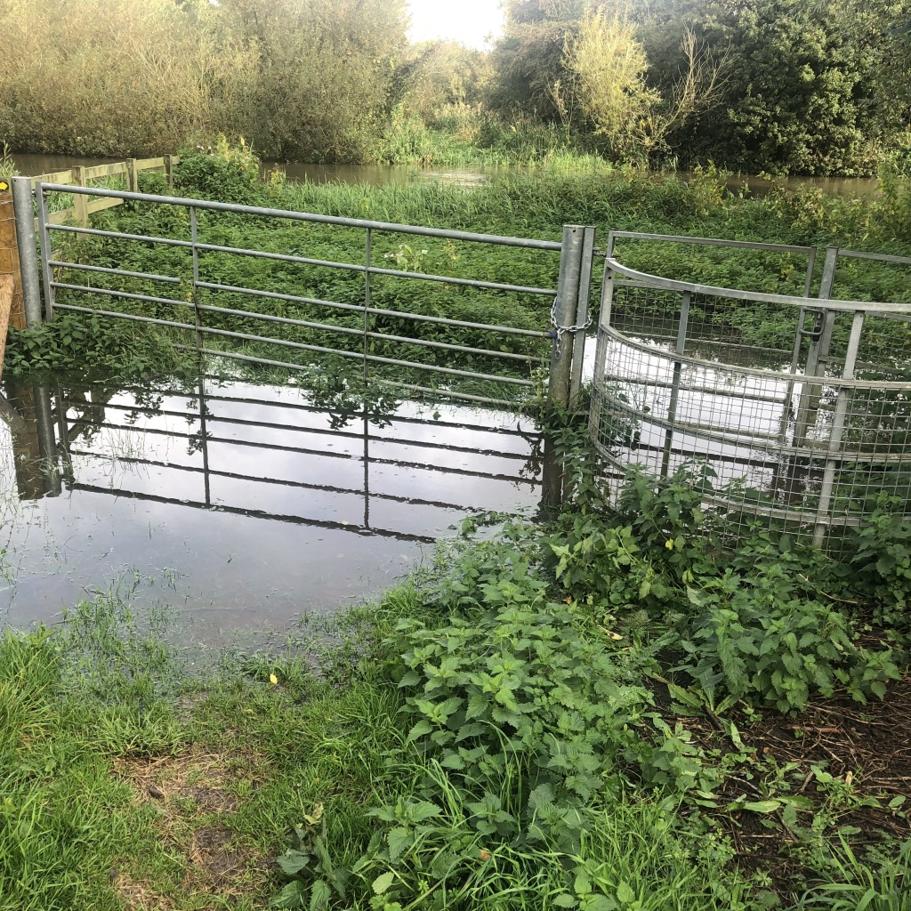
POINT 8
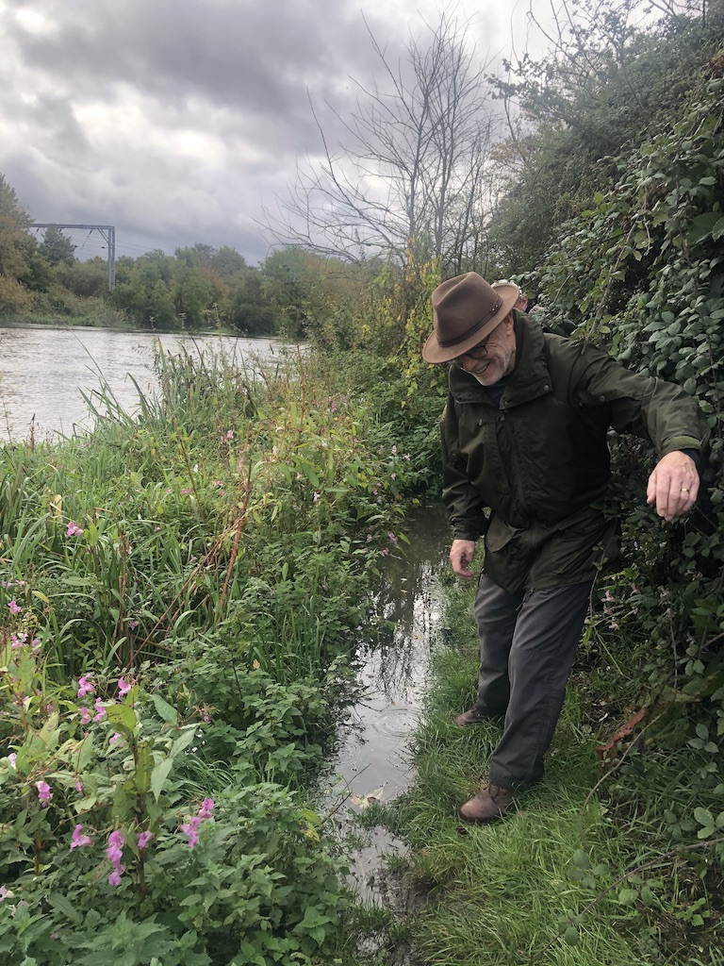
POINT 13
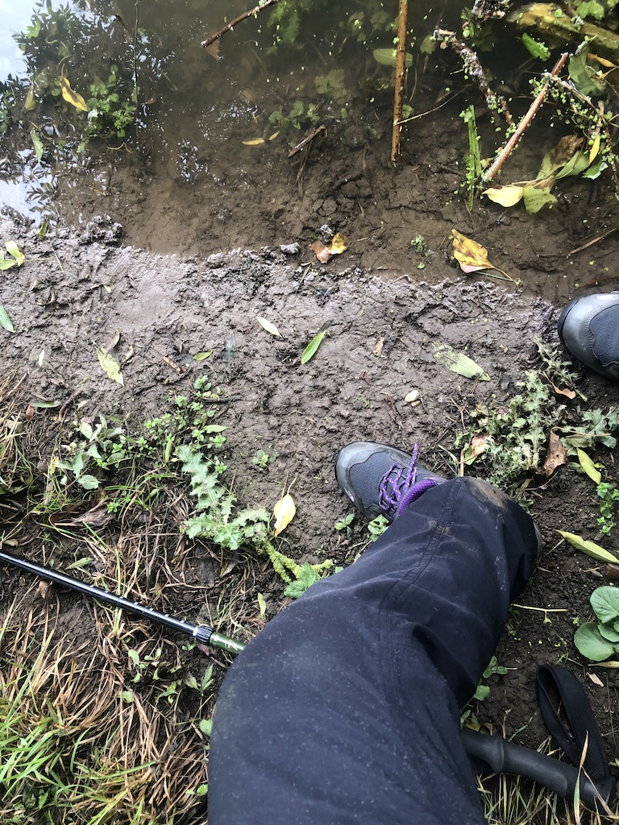
POINT 15
