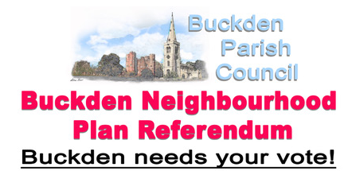
WHEN: 6th May 2021
Please put the date in your diary
WHERE: Methodist Hall, Church Street
You can vote in person or you can use your postal vote.
WHAT: The Buckden Neighbourhood Plan is complete, has been approved by a Planning Inspector, and by Huntingdonshire District Council. The last step in the process is approval by parishioners in a referendum.
You can view a copy of the Plan on our web site buckdenpc.org.uk.
If you would prefer to see a paper copy, please contact the Clerk on 01480 819407.
WHY: you should vote for the plan:
- Gives us greater control and influence over development of all types in the village.
- Includes policies relating to Housing type and design, Traffic, Flooding, Biodiversity, Footpaths and Cycle ways, Services e.g. School and GP Surgery.
- When development takes place, the village receives considerably more money to spend on local facilities.
- The policies are already being considered in relation to the Silver Street development.

