Summary of issues with Lucks Lane attenuation ponds March 21

The residents of The Osiers and Springfield Close are very concerned about the high level of water in the attenuation pond at the rear of their properties.

In January a group of officials were noted examining the water level and the area around the pond; and subsequently a water bowser/tanker (name on the truck’s side is ‘BINDER’) was brought in to pump water from the culvert area of the pond.

This potential for groundwater and surface water flooding of the area was drawn to the attention of the initial developers, the HDC, Anglian Water and the local flooding authority and the Government Inspector during the initial planning phase. All overruled residents’ concerns, stating that sufficient drainage would be put in place to cover any weather eventualities.

Since then the ground level of the site has been raised significantly (there are ground levels at the north of the site which are on a first floor level of existing housing in The Osiers).
The attenuation ponds to the south of the site are not as full as this pond at the junction of Osiers/Springfield, this may be because this latter pond is on the site of a spring.

A major concern of local residents is: who will protect them from flooding once the construction is finished?

The PC informed CCC of the issues and, at the end of January, Hilary Ellis, Principal Sustainable Drainage Officer & Flood Risk Contract Manager, met with Bloor and HDC to discuss the issues. She informed the PC that Bloor were going to come back to CCC later in that week with plans of how to manage the drainage and that she would keep us updated.

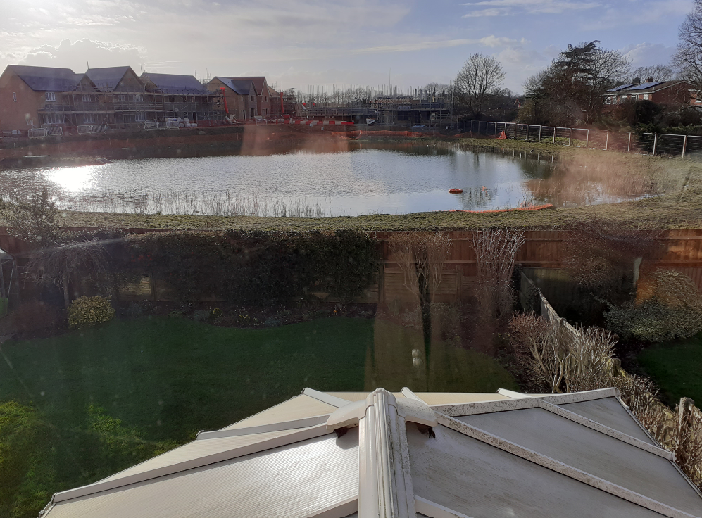

The above recent photos illustrates that the water level in the attenuation basin can be higher than the adjoining gardens and would continue to rise without intervention. Residents are deeply concerned about the risk of flooding to their properties. In the photo it hadn’t rained for a few days and the picture was taken under blue skies, which aptly illustrates the groundwater issues in Buckden.

The lead Councillor from the PC dealing with this issue asked that CCC share the solution with the Council after it is presented to them. We have not yet heard about the attenuation ponds, CCCs meetings with Bloor or any plans which Bloor may have to alleviate the situation.

At the end of February a resident contacted us with continuing concerns about the attenuation ponds. The eastern attenuation pond had a very high water level, higher than when Bloors used bowsers to extract water.

Once more we raised it with CCC and we received the following assurances from Harry Pickford Senior SuDS & Flood Risk Officer

Thank you for raising this with us and sending the photos of the water levels in the basin.

I have spoken to the Engineer from Bloor Homes regarding the water levels and he is now aware of the issue. He is going to contact the Site Manager and look to pump the water from the basin, into the other basins which are infiltrating across the site with the lower groundwater levels, same routine as carried out last month. They are aiming to do this over the weekend.

I hope this helps and will update you further should I hear anything else.

We have heard nothing since; residents in the houses near the site and pond are still concerned on the following matters:
- Bloor appear unaware of the state of the attenuation ponds on their site, taking action only when alerted by us or others.
- The bowser in January emptied the overflow water into the public drains not into the, then, almost empty other attenuation ponds.
- The other attenuation ponds are now also full and cannot take the excess from the eastern pond.
- The height of water in the attenuation ponds appears to have only a partial correlation with rainfall in the immediate Buckden area, perhaps indicating that the springs under the site and especially that beneath the eastern pond are fed by underground water from other sources.
- Despite Bloor’s assurances they have provided no medium or long term solution to this flooding problem. Meantime, construction and sales continue apace….

We are asking CCC to meet with Bloor again, to discuss the above with them and advise Buckden Parish Council of what workable plans are in progress for keeping our homes safe from flooding. On a wider issue we would like the underlying aquifers and surface water drainage systems to be mapped and potential flood events modelled before further development continues. The Planning Inspector’s decision was clearly wrong, and villagers’ concerns were ignored when the Lucks Lane development was granted on appeal. The Parish Council does not want a similar situation to occur with other potential developments in the village – a more holistic approach is needed.

At the end of April it was noted that landscaping seemed to be starting around the basins. The Parish Council has requested more information.

