How to plant a tree  dIG YOUR HOLE  Dig a shallow square hole 3 times the width of the roots and deep enough that the top of the first root is in line with ground level  PREPARE YOUR TREE  Bare root trees – soak in water for 30 minutes before planting. Potted trees – give them a good drink of water first.  STAKE  Place a low stake upright or at an angle next to your tree. The aim is to attach the tree approx. 30-50 cm above ground level.  PLANT YOUR TREE  Place the tree in the hole and, holding it upright, back fill with the soil you dug out. Gently firm around the roots with your feet.  TIE & WATER  Tie your tree to your stake, not too tightly. Give your tree a good water, 2 watering cans full over 10 minutes is a good guide.  MULCH  Apply 5cm thick mulch across the planting area, leaving a gap near the stem to prevent rotting. Compost or wood chips are good for mulching  Learn from the experts at the Woodland Trust or the RHS:  https://www.woodlandtrust.org.uk/plant-trees/advice/how-to-plant/  https://www.rhs.org.uk/Advice/profile?pid=237  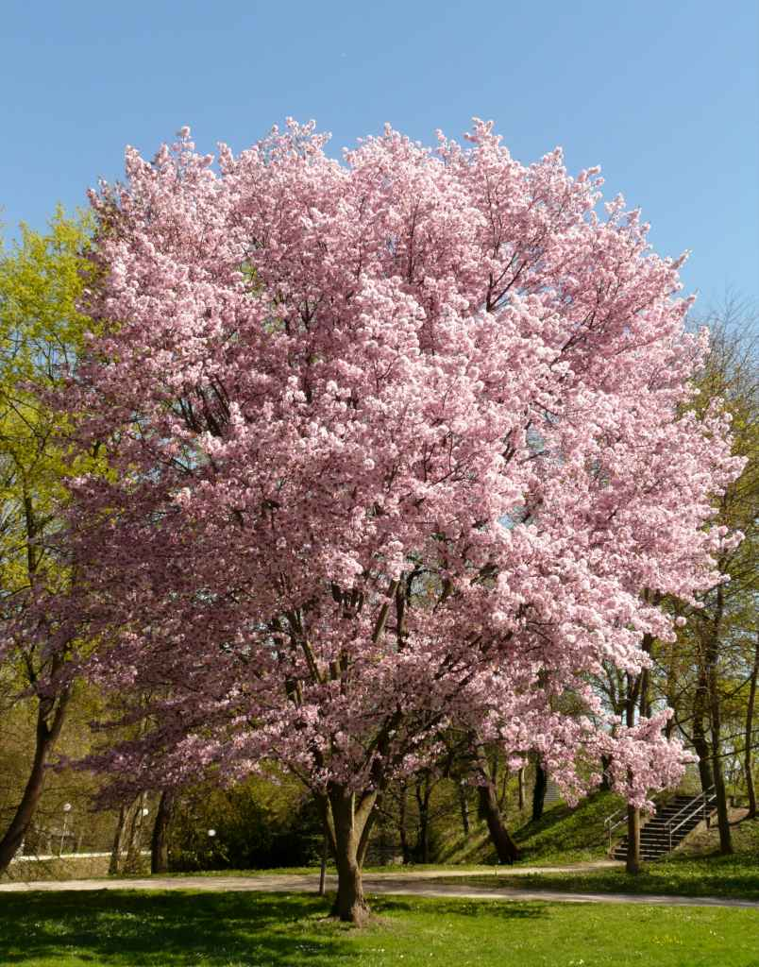 | share your tree/s  We would love to chart our success in making Buckden a greener place. Please can you let us know if you are intending to plant a tree?  If you could send the following information to clerk@buckdenpc.org.uk with the words ‘planting a tree’ in the subject line that would be really helpful:  - location  - number and type of tree/s  Share pictures of your tree/s and the fun you and your family have had planting your tree, on the Buckden Parish Council or Buckden Residents Facebook page  https://www.facebook.com/buckden.parishcouncil.1  https://www.facebook.com/groups/1594474184137795  TPO (Tree preservation order)  If you think a tree may be at risk of being damaged or removed and want to know if it has a TPO or feel it should have one, then let the Parish Council know. More information can be found about TPO’s here:  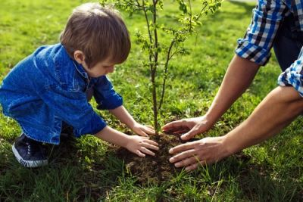  https://www.gov.uk/guidance/tree-preservation-orders-and-trees-in-conservation-areas
  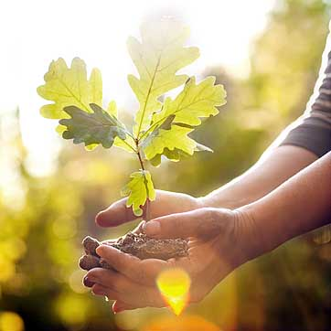
  PLANT A TREE
  BUCKDEN
  &
  DIDDINGTON

The Value of Trees  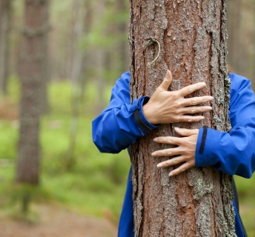  “Trees are essential to the future of the planet” Sir David Attenborough  dIG FOR BUCKDEN & DIDDINGTON  PLANT A TREE  Cambridgeshire needs more trees to help the wildlife and us live healthy, happy lives. It would be great if you could find a space in your garden for a tree or two. Choosing a tree requires a bit of forethought, as you need the ‘right tree in the right place’ so here are some things to consider and links to further information to help you along the way.  WHY PLANT A TREE?  - Absorbs carbon from the air  - Flood prevention  - Reduces erosion  - Provides a home for all kinds of wildlife  - Provides nesting habitat, food and cover for birds  - Provides shade and shelter  - Reduces stress and improves mental health | cHOOSING THE RIGHT TREE | Planting and purchasing
 | WHICH TREE?  Choosing the right tree will certainly help your tree to thrive and increase your enjoyment of it  - What is important to you: autumn colour, shape, fruit or nuts, interesting bark, evergreen leaves, colourful flowers, ability to support wildlife or creating a family legacy?  - Do you need your tree to not exceed a certain size, or do you want it to grow quickly?  - What grows well locally in your soil conditions?  - Do you need to be sure that in time its roots and/or canopy will not prove a nuisance to others’ land or property?  - Native deciduous trees are the tree of choice, they provide homes and food for a huge variety of wildlife, will change during the seasons and can provide spectacular spring blossom and autumnal leaves  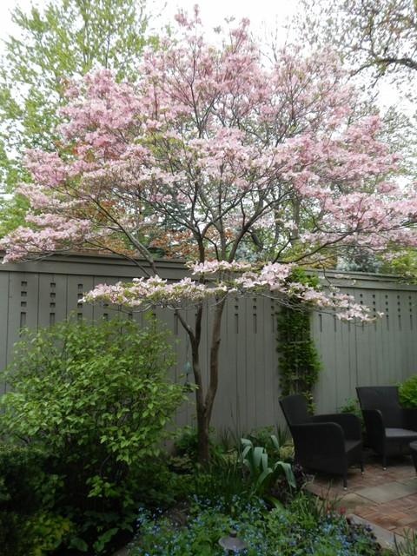  We encourage you to plant native trees as these not only look fantastic, they are the very best for our amazing range of local wildlife, from birds and bugs to bees and bats. The level of biodiversity in a hedge of native plants vastly exceeds that of a somewhat barren strip of land planted with Leylandii. Have a look here: https://www.woodlandtrust.org.uk/media/1168/twigged.pdf and https://www.woodlandtrust.org.uk/blog/2019/03/british-trees-to-plant-in-your-garden/ | 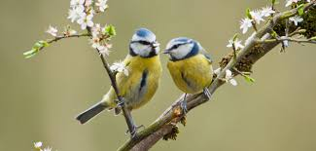  WHERE TO PLANT  Identifying the position will help you decide which tree is right for you  - How much space do you have to accommodate your tree as it grows to maturity?  - Make sure that your tree will not cause nuisance or damage to your property or others or buried utilities as it grows (Leylandii trees are best avoided because of this)  - Are you trying to create shade, a windbreak, a screen or simply want to enjoy your tree from a certain window?  - Check your site conditions, is the soil dry or moist, rich or poor, sunny or shaded?  - Is your tree deciduous or evergreen, single or multi stemmed, vigorous or slow growing?  Buying a tree  Buying a new tree can be exciting but also confusing. It is important to consider factors such as full-grown size, roots, and suitability for the garden. This leaflet will help you decide on your requirements before buying.  Find a good tree nursery that offers UK sourced and grown trees to prevent the spread of imported pests and diseases. Buying local is always good!  If you don’t have space yourself, you could give one as a gift to a friend or family member

