Healthwatch Community Researchers role toolkit
Resources to help you promote the role to people in your community.

Suggested article for your websites or newsletters
Get in touch if you want any help doing something more personalised for your organisation.

Volunteer as a 'Healthwatch Community Researcher' to help improve how services work for local people
And be part of a small team listening to the views of local people and making recommendations to improve care. You will receive an involvement fee of £75 per half day for the time you give, excluding training. You’ll also receive out of pocket expenses.

Local NHS and care services want to recruit 15 people across Huntingdonshire, Peterborough and Fenland for a new community listening project.

As a Healthwatch Community Researcher, you will talk to local people about services, including those provided by hospitals located in the regions covered by this project. And you will listen to the views of people with long-term conditions, like diabetes, and those who find it hard to access services. This role will include running co-designed and co-produced surveys, workshops and patient interviews, and writing reports.

You don’t need research or report writing experience as you’ll get training and support from the Healthwatch team.

Healthwatch Cambridgeshire is managing the Healthwatch Community Researcher programme for local health and care teams. It makes sure NHS leaders and other decision makers hear your voice and use your feedback to improve care.

Find out more and how to apply: Volunteer as a 'Healthwatch Community Researcher' to help improve how services work for local people | Healthwatch Cambridgeshire

You can also call Healthwatch Cambridgeshire on 0330 355 1285 or text 0752 0635

Suggested social media posts
We have prepared a range of images that you can choose to share with your posts – so we are targeting different sections of the community.
Please tell us if there’s anything you would particularly like to see – e.g., a picture that represents a particular community.

Facebook
Facebook is the top performing platform to target people in the community. You can share on your own Facebook page if you have one. We also recommend speaking to any pages that cover your community asking them to share your post.
Wanted: 15 new Healthwatch Community Researchers to help us provide better health and care for local people.  This new volunteer role is all about listening to your local community in Huntingdonshire, Peterborough and Fenland.  We want to hear how certain services are working and how to make them work better.  Work with us on surveys, interviews and workshops. Then share your findings to help us learn and build better services for everyone.  You get training, support and an involvement fee.  Find out more: Volunteer as a 'Healthwatch Community Researcher' to help improve how services work for local people | Healthwatch Cambridgeshire | 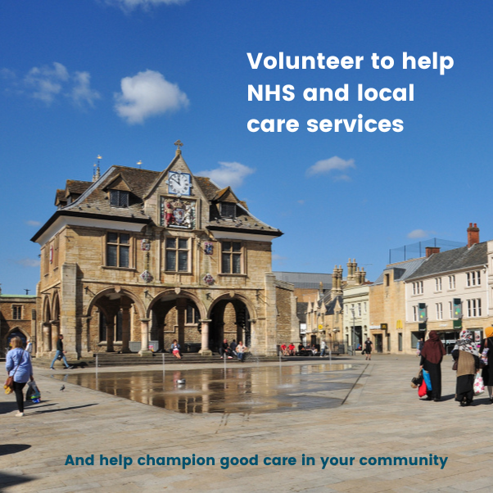
What do people in Huntingdonshire, Peterborough and Fenland think about local health services?  Help us find out and build better care by becoming one of our 15 new Healthwatch Community Researcher volunteers — and be remunerated for your time.  Sign up for our exciting new community listening project and you’ll meet new people, learn new skills and help local services work better together for everyone.  Work with us on a few key projects over the next 18-24 months — you’ll get training, support and an involvement fee.  Plan surveys, interviews and workshops to get people’s views. And help us learn how to give better support — especially to people who find it hard to access services.  Find out more: Volunteer as a 'Healthwatch Community Researcher' to help improve how services work for local people | Healthwatch Cambridgeshire | 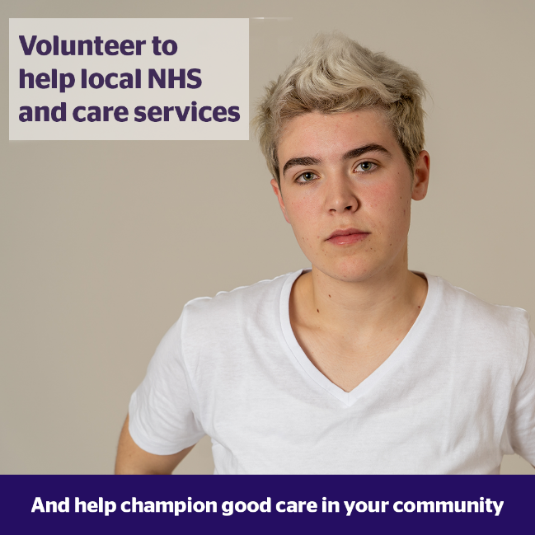
Interested in volunteering? Here’s an exciting opportunity to make a difference to the health of local people.  We’re searching for 15 Healthwatch Community Researchers to work with us to build better health and care services in Huntingdonshire, Peterborough and Fenland.  Get involved in our community listening project and help us learn by talking to people in your patch.  You’ll get training, support and an involvement fee for your time.  Find out more: Volunteer as a 'Healthwatch Community Researcher' to help improve how services work for local people | Healthwatch Cambridgeshire | 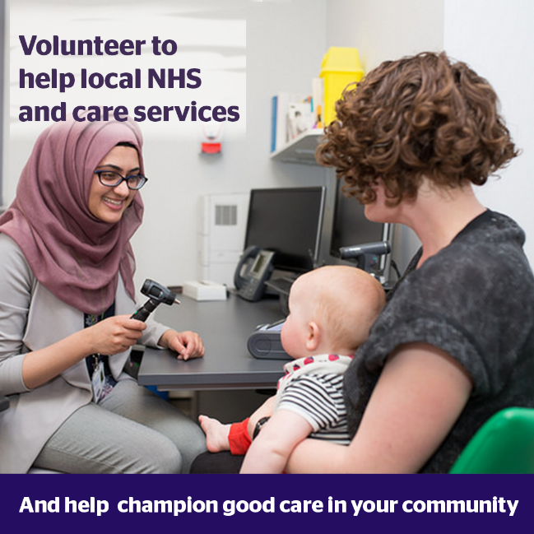
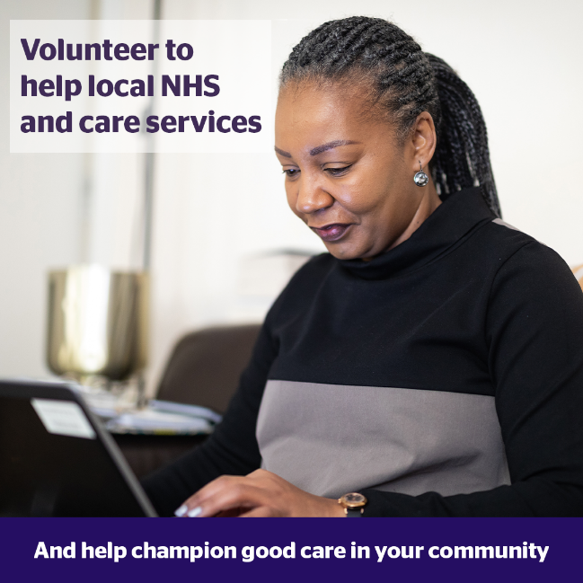 | Be one of our 15 new Healthwatch Community Researchers and help the local NHS and care services build better care for local people.  Plan surveys, interviews and workshops to get people’s views in your patch in this community listening project.  You’ll get training, support and an involvement fee for your time.  Volunteer as a 'Healthwatch Community Researcher' to help improve how services work for local people | Healthwatch Cambridgeshire

You can share any of the above images on Instagram but will need to adapt the text to direct people to our profile. Here’s an example below:
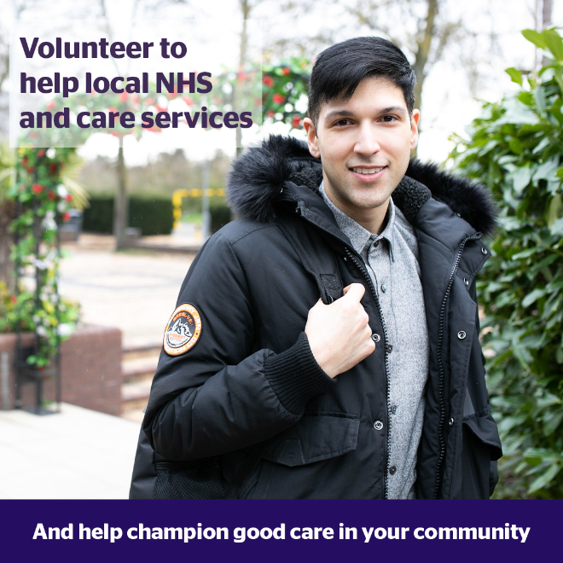 | Become a local Healthwatch Community Researcher and help with a new project to improve care in your area.  Local health and care organisations – including ours – are working together with Healthwatch to find out what people think about services.  You will plan surveys, interviews and workshops to get people’s views in your patch in this community listening project.  You’ll get training, support and an involvement fee for your time.  Find out more from @healthwatchcambspboro

Tweets
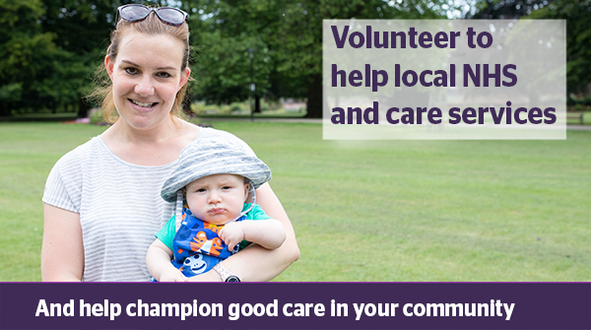

Help build better health and care in #Huntingdonshire, #Peterborough & #Fenland.

Become a volunteer Healthwatch Community Researcher in a new community listening project to help us learn from patients' experiences.

You'll get training, support and an involvement fee.
Volunteer as a 'Healthwatch Community Researcher' to help improve how services work for local people | Healthwatch Cambridgeshire

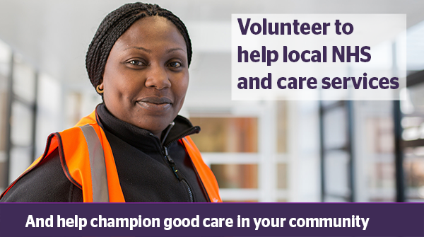
Interested in #volunteering? Become a local Healthwatch Community Researcher.

Plan surveys, interviews and workshops to get people’s views in your patch in this community listening project.

You’ll get training, support and an involvement fee.
Volunteer as a 'Healthwatch Community Researcher' to help improve how services work for local people | Healthwatch Cambridgeshire

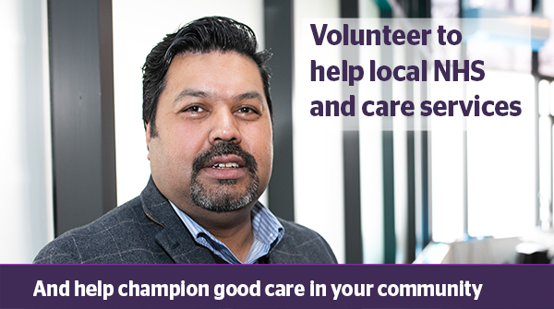

Join a new project we are part of and be a #volunteer Healthwatch Community Researcher.

Find out what people think of services in Huntingdonshire, Peterborough and Fenland.

And help us improve them.

You'll get training, support and an involvement fee.
Volunteer as a 'Healthwatch Community Researcher' to help improve how services work for local people | Healthwatch Cambridgeshire

If you prefer, you can share social media posts directly from Healthwatch Cambridgeshire’s social media feeds.
We are on
- Instagram – @healthwatchcambspboro/
- Facebook - @HealthwatchCambsPboro/
- Twitter - @HW_CambsPboro

For more information
Contact Paul Gould, Communications Manager at Healthwatch:
- email at paul.gould@healthwatchcambspboro.co.uk
- or by mobile on 07355 916054

