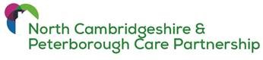
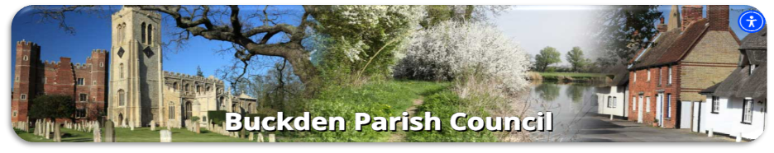

Buckden Parish Council is in early discussions with the North Care Partnerships Integrated Neighbourhood Team about developing a Community Health & Wellbeing Hub for the residents of Buckden.
The Integrated Neighbourhood Teams work with partners across health, social care, and the independant and voluntary sector, making sure that wider determinants of health and wellbeing are addressed.
The primary purpose of the Integrated Neighbourhoods is to ‘Support people to stay well, be independent and live happier and healthier, ensuring every person matters and every contact counts’.
This includes:
- Activating people to care about and take control of their health and address prevention, using meaningful conversation.
- Supporting Health Inequalities
- Targeting the most vulnerable residents to offer support – Make every contact count
- Facilitating community engagement – offering support routes/pathways
A key priority is to create Community Health & Wellbeing hubs.
A hub:
- Identifies all the support services that are currently available locally,
- Makes sure that all services are well advertised, and
- Coordinates and enables referral between the services. For example, a GP may decide that a patient would benefit from more exercise and social activity and refer them to a Walking Group and/or a social group.
In Buckden many groups and activities already exist. Working collaboratively with the Integrated Neighbourhood Team, we would like to understand which services are currently used, by whom, what people would like to see made available, whether that be related to health, social or care aspects, and where people go for support.

Section 1

  - Do you attend any community groups in your local area? If so, which ones?

  - What do you enjoy about attending community groups?

  - Do you rely on public transport in the area?

  - What sorts of community groups or activities would you like to see in your area?

  - What do you think could be done to improve the quality of life in your area?

  - Would you like to meet more people socially?

  - What sorts of Health or Care services would you like to see in your area?

  - If you needed help/support where would you go or who would you speak to? (Please tick)

Friends

Family

Community Group

GP

Other

  - Where do you access information about what’s going on in your community?

Section 2 – Data Capture Information
We appreciate you sharing your experiences with us. This survey collects information anonymously and helps us ensure that we are collecting feedback from a variety of ages, ethnicities and locations.
- What is your age?

Under 16
16-29
30-44
45-59
60-74
75 years and over

- What is your ethnicity?

- What gender do you identify as?

